**HAN22080311**

**MOM, I'M SORRY**



|  |  |
| --- | --- |
|  | The game is called "Mom, I'm sorry" - a game about family feelings. This game is scheduled to launch on Steam and PlayStation platforms in December 2040. The target age of players is over 12 years old, with an Age Rating of E. The price of this game will be 50$ and 20$ for each DLC. |

**Game Story Summary**

* Anna is a widow living with her son - Jack, in a small house near the beautiful lake. It is ten years since the dad's death; Jack is 15 now. Not one day, not even one hour, Jack constantly argues with his mom; although Anna wants to be good for him; they do not have any connection to solve the problems. He has five toys that his dad bought on Jack's Birthday. Then one day, Anna is sick for a specific reason (Jack says to his mom: " I wish you were the person who died with the epidemic, not dad."). Because it just has two people in a family, Jack has to take care of his mother. He spent a sleepless night looking after his mom. In his dream, he meets the toys again and looks back at what his mother gave him in the past. Jack must collect five tears after meeting each toy to save Anna.

**Game Flow Outline**

* "Mom, I am sorry" is a third-person single-player adventure game where teenage Jack finds five tears in a dream world. He needs to find five of his childhood toys to preserve his memories. The player needs to find the item or do what the toy asks, and when he returns, the toy will give Jack a tear. The dream world will have five islands in the clouds for Jack to explore: four surrounding islands and a large island in the middle. (As the picture has shown). All of these islands have Disney cartoon themes which suitable for each toy. The way for the gameplay to connect with the story is for Jack to discover that there will be emotional childhood memories behind each toy, the sacrifices that Anna's mother made for Jack. The winning condition is to find five tears from five childhood toys and save Anna from illness.

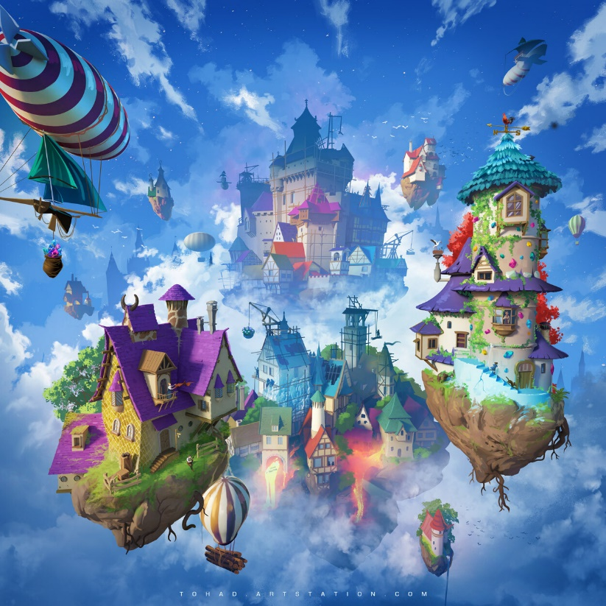

**Characters and Controls**

* In the beginning, there will have a video of about 3-4 minutes from Jack's childhood at 5 years old when his dad died, he hugged 5 toys in his arm. After that, there were many fights between Jack and Anna over the next 10 years. And when he was 15 years old, Jack suddenly said, "I wish you were the person who died of the epidemic, not dad."
* Jack and Anna look like the pictures shown below.

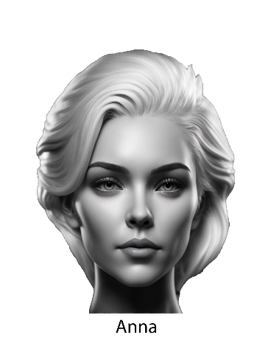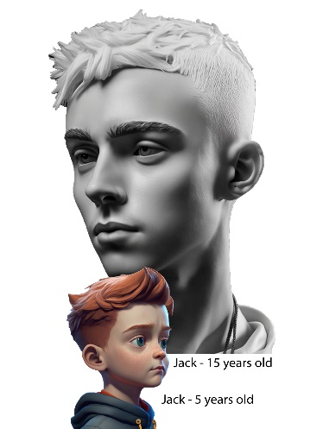

* Anna is pretty and always cares and takes care of Jack. Her way of speaking is too heavy and not very gentle, making Jack hurt and think that mother loves herself and always only wants what is good for her. Anna did not love her son.
* Jack inherited the beauty of his parents. Brown hair from his father and green eyes from his mother, the naughty features on his face appeared from when he was 5 to 10 years old, stubborn and disobedient.
* When on the island of dreams, Jack needs to understand his mother's feelings through memories of toys.

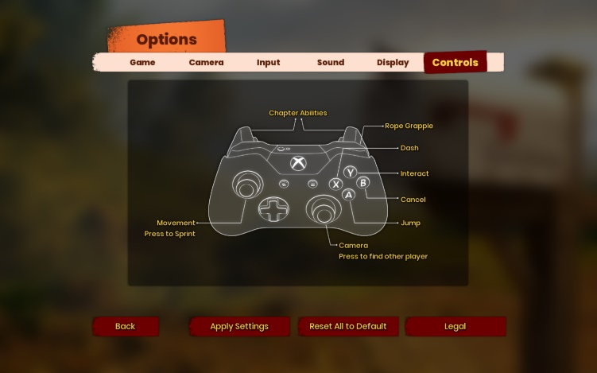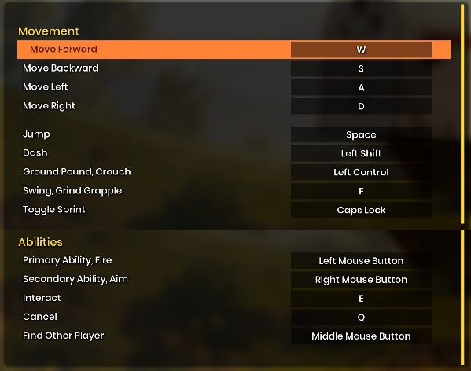

Controls of controller and keyboard (From It takes two)

**Gameplay**

* The game has five story chapters according to 5 themes of Disney characters divided into five different islands. When the character defeats the monster, collected a tear of the leading toy on that island will be moved to the next island. The game level will go from easy to difficult; the following islands will have those solutions, or boss monsters will be stronger than the previous islands. The most complicated island is the last one (the middle island).
* Players cannot choose which island they want to explore next. All chapters are pre-set in sequence. Only when the player has cleared the game (rescuing Anna's mother) can they choose to play an island again in the Menu.
* On each island, the player will have 2 Minigames, and five islands will have 10 Minigames in all—minigames for two players. Jack and the main character in that film (NPC) will fight each other (players choose three modes easy, normal, and hard) to see who wins. If Jack wins, he will have a +1 hint to solve the puzzle. Players can play Minigames repeatedly but only have a maximum of 3 times for free. They can buy more turns of Minigame at a store in-game (I will explain this on page 10)

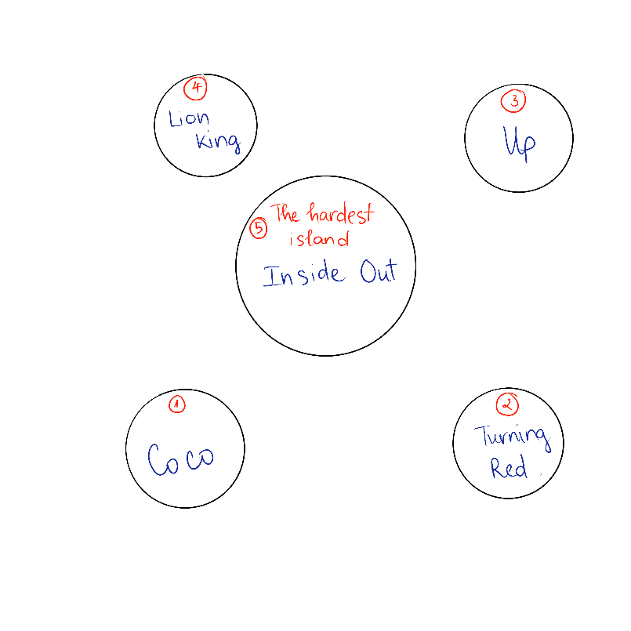

The map of the Dream World

**Game World**

* The stories on each island are closely linked with Jack's purpose to save his mother. Moreover, those stories help Jack understand more about how Anna's mother sacrificed for him through the toys that his father sent.
* The first will be the island from the movie "Coco" with the figure "Miguel Singing." The film tells the story of a boy named Miguel who is not allowed to pursue his passion for the guitar but is forbidden by his family. With this island, players will see that Anna's mother has worked hard day and night to have conditions for Jack to go to drawing lessons - Jack's passion and to buy enough learning tools not to let the boy lack. Furthermore, Miguel helps Jack understand that he is fortunate to have a mother who is always supportive in all conditions to chase his passion despite his family's poor circumstances.

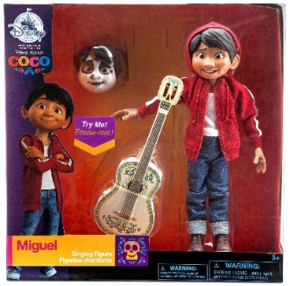

Miguel from “Coco” & Red Panda from “Turning Red"

* The second island is "Turning Red," with Red Panda as a toy. Mei Lee is a little girl who always tries to do well in school and please her mother (Ming), but her mother accidentally humiliates her publicly. By the film's end, Mei makes peace with her mother, and Ming has also accepted that her daughter is finding her way. From there, the player sees Anna's mother sometimes shouting at Jack publicly and hurting the boy. Moreover, Jack realizes they must talk seriously about this problem so that Anna's mother can correct the mistake.
* The movie "Up" is attached to the third island, and the toy Jack was given by his father is the character Carl. With the movie's message, the relationship is a real adventure, and it is too late to appreciate when they are gone or what we have lost. Through the conversation between Carl and Jack, he understands the importance of the relationship between people, especially the relationship between family, and Jack only has his mother as a relative.

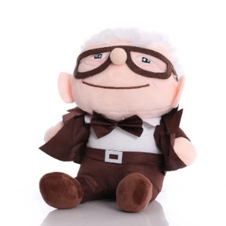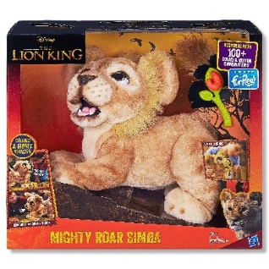

Carl from “Up” & Simba from “Lion King"

* The fourth island is associated with the movie "Lion King," the character leading the story is "Simba." Giving his son this toy while he was seriously ill, the father put all his love into it. Simba and Jack have in common the loss of their father at an early age along with the difficulties in life, plus a lesson in the repetition cycle of life. Jack's father wants his son to grow up to protect his mother, accepting responsibility.

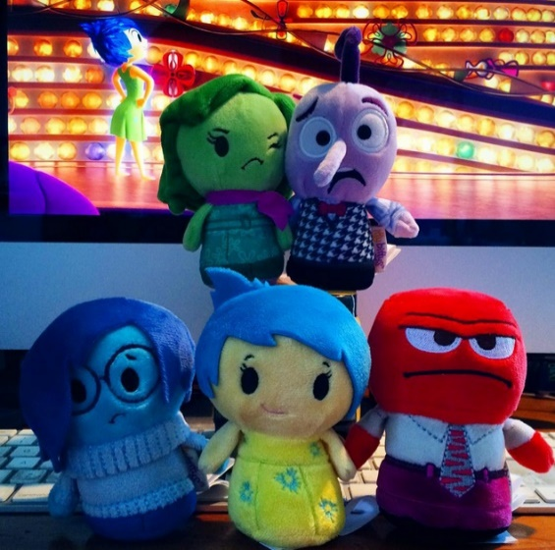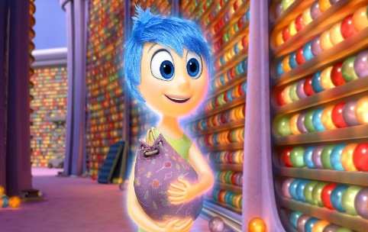

Emotions & Memory Balls from “Inside Out”

* The last island is also the most challenging in the middle of the map. With this "Inside Out" island, five characters will lead the story. Those are Anna's feelings from when she found out she was pregnant until she became a single mother of a teenage child. Jack will witness Anna's journey through memory balls. Since then, Jack acted and said rude things to his mother. Moreover, the tear on the fifth island turns out to be Jack's.

**Gameplay Experience**

* "Mom, I'm Sorry" is a touching family game. Players will be promised different emotions: sad, funny, happy, and emotional. Players will see a short video about Jack and his mother's fight until Anna falls ill.
* The game's background sound will change according to the emotional circuit of Jack's character. When Jack quarrels with his mother, it will be different when he cries. When the player affects something in the game, the sound effect will be the same as in real life.
* To enhance the experience of the game, when the player uses the controller, the vibration mode will be activated when interacting with objects, especially when fighting the boss. Every time the boss knocks the character down, the handle will vibrate. In addition, a cutscene will be played when talking about the past, which will help players better understand the game's plot.

**Mechanics and Modes**

* Jack can double jump and dash on the ground. Each island has a different mechanic for a character. In "Up" Island, Jack is equipped with flying balloons behind his back. In "Coco," the character can penetrate walls. Moreover, in "Lion King," Jack has Pumba (Mister Pig), which allows the player to ride on his back. This can help the character move faster. In "Turning Red," Jack can transform into Red Panda quickly, and in " Inside Out" Island, there have some challenges for Jack to use five emotions to swindle some NPCs.

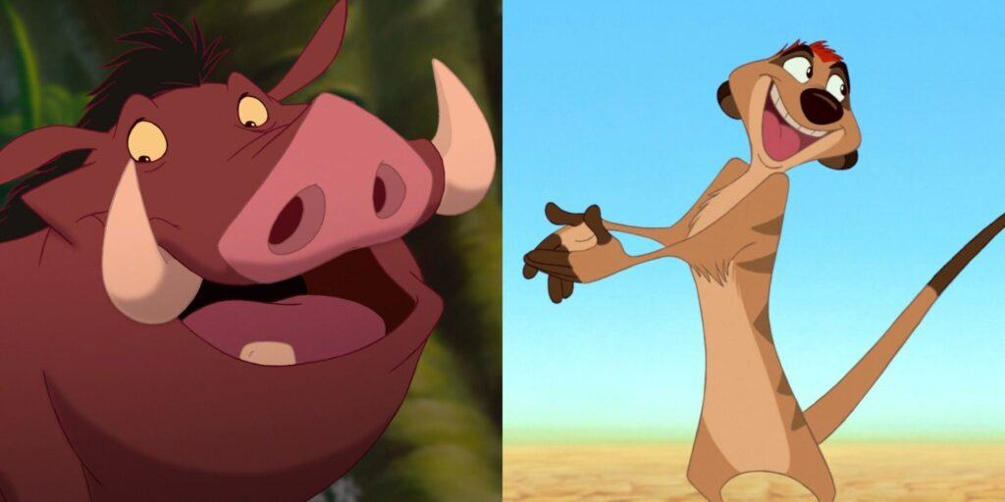

Pumba (Mister Pig) from “Lion King”

* For the minigames, Jack has to compete with the main character of that island; especially in the "Inside Out" game, we have six characters, including Jack, and the minigame will be divided into two groups.
* Moreover, in the DLC of the characters in the movie (buy in a store in the game - I will explain this on page 10), players will experience the new mechanic, which is player choices. With each choice, the story in the DLC will go in a different direction. Therefore, players can repeatedly play the DLC without getting bored to find the side stories.

**Enemies and Bosses**

* Jack will fight with the boss enemies on each island in different ways, with different weapons or abilities.
* "Coco": The boss is Ernesto de la Cruz with the enemy's weapon, which is bones. Jack has the guitar. When it plays, it produces musical notes that damage.

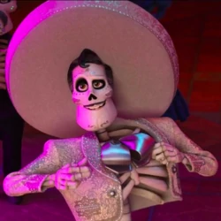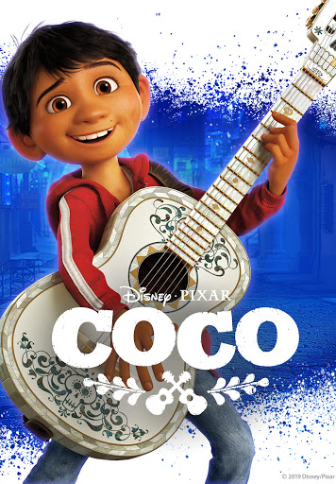

Ernesto de la Cruz & the weapon for Jack

* "Turning Red": The boss is Ming Red Panda - Mei's mom when she altered. She has the punches which seal the significant damage. Jack has the sword.

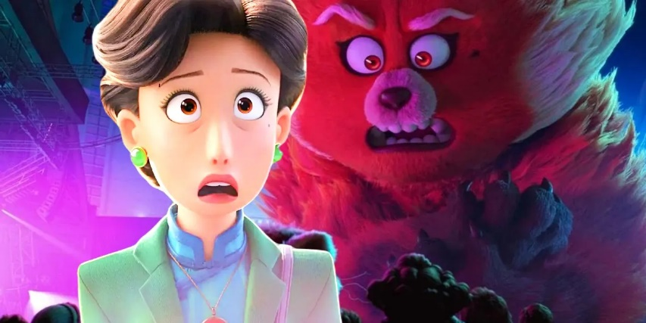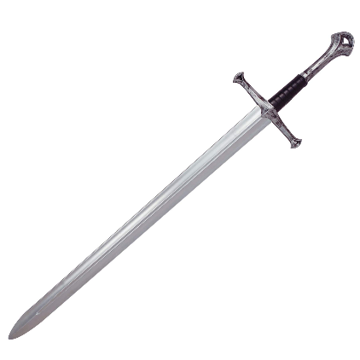

Ming Red Panda & the sword for Jack

* "Up": The boss is Charles Muntz with a hunting gun. Jack has a tennis ball gun.



Charles Muntz & the tennis ball gun for Jack

* "Lion King": The boss is Scar with The Hyena Clan. Jack with Pumba will fight with that enemies.

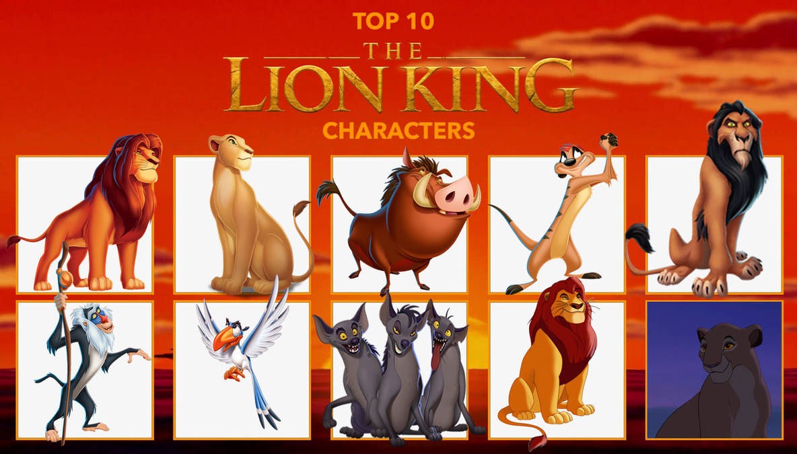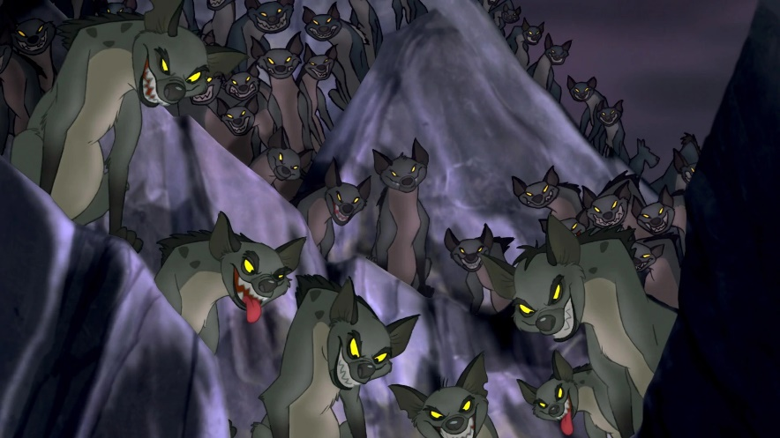

Scar with The Hyena Clan

* "Inside Out" does not have enemies. This island will focus more on the past and Jack's emotions.

**Bonus Material and Downloadable Content**

* The game is single-player, and the islands will be unlockable for the player to keep playing "Mom, I'm sorry.". There will be six achievements to be awarded:
* Unlock all the islands.
* Play all the minigames.
* Win all the minigames.
* Fight all the enemies.
* Unlock all the DLC.
* See all the cutscenes.
* The player cannot create or share the content in games.
* Each island will have DLC about that main character's story. The player can buy it to experience.

**Monetisation**

* Players can purchase the hint of puzzles in-game or the turns of Minigames. Moreover, the players can buy the DLC of the main character of each island. These contents do not affect the gameplay. The DLC is just for Jack to experience the Disney movie again but in the way playing. The character can go everywhere in the game if he wants.